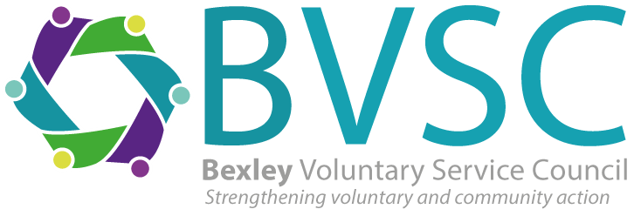

BEXLEY VOLUNTARY SERVICE COUNCIL

Community Connect Wellbeing Coordinator (4/5 days)

Salary £26,212 including OLW (Pro Rata of £32,770)

Due to a recent restructure within the organisation, BVSC are seeking a Community Connect Wellbeing coordinator, who is passionate about improving health and wellbeing within Bexley. In this role, you will work within a team to empower residents to access local charities, community groups, and services. Working alongside healthcare professionals and local organisations, you’ll help create personalised action plans, provide ongoing support, and ensure that everyone receives the care and guidance they need.

Closing date for applications is 5pm Wednesday 14th May 2025.
Interviews are likely to be held on Wednesday 21st May 2025
Please send your CV and a covering letter, outlining how you fit the criteria and why you would like the position, to info@bvsc.co.uk

Application pack and full job details here

Don’t meet every single requirement? At BVSC we are dedicated to building a diverse, inclusive and authentic workplace, so if you’re excited about this role but your past experience doesn’t align perfectly with every qualification in the job description, we encourage you to apply anyway. You may be just the right candidate!

BVSC, Engine House, 2 Veridion Way, Erith DA18 4AL
Tel: 01322 524682.

Charity No. 279880
Company Limited by Guarantee 1501746

