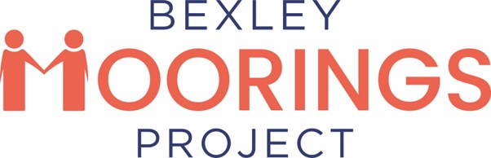

CYP-PT Therapy Trainee (Formerly CYP IAPT)
(CBT Strand) x 2
London Borough of Bexley

Full-Time
33k per year inclusive

Contract

Job description
This is an exciting opportunity to become part of the strategy to increase access to evidence-based interventions to children and young people with mild-moderate levels of anxiety and/or depression.
This intensive 1 year training post starting January 2026 will equip the postholder to provide interventions based on CYP-PT principles which are consistent with the CBT training course. The post is split between training based in London through NHS England/Kings College London/virtual (post graduate diploma) and direct therapeutic work based within Bexley Moorings.
If you have suitable experience/qualifications and an interest in working with young people in a mental health environment and would like to further develop your skills this might be the post for you.
Points to note before applying:
Former EMHP and CWP graduates (or graduates from any other HEE funded course) need to be 2-years post-graduation to be eligible to apply (graduated by January 2024).
Training Information
This full-time training will begin in January 2026 with around 2.5 days a week for academic work (teaching and personal study), and 2.5 days based at the service seeing clients related to training assignments. Trainees will be both an employee of the service and an enrolled student with King’s College London. Upon completion, qualified trainees will receive a KCL Postgraduate Diploma.
Applicants must be prepared to study and write assignments outside of protected study time (such as on weekends and after work).
Application Process
This is a dual application process. In addition to applying for this position with us, you must also complete a KCL application for the Course Team to review. The Course Team will liaise with us on whether you meet the academic requirements for the course during the recruitment process. You will only be offered a KCL training place if you are successful in securing this post and you meet the university training requirements (such as academic background, relevant experience, visa approval).
More information about the course including minimum entry criteria is included with the job application pack. The pack can be requested through Bexley Moorings email listed below.
info@bexleymoorings.co.uk
Please note that when you apply to this role, your name will be shared with the Higher Education Institute (HEI) running the course. The service will usually be the Course Team’s main way of contacting you until you have been sent an Offer, and so the Course Team at the HEI may ask for information if it is missing but relevant to deciding eligibility. Other information that might be shared is:
- Reason behind ineligibility for the course.
- Queries regarding application (such as if you claim to have a professional registration without submitting certificates, the Course Team may ask the Service to pursue more information)
- Name change – if you have registered with a different name than HEI was given, they will confirm with the Service to ensure that they are reviewing the correct candidate.

This is an integral part of the process to confirm that you have applied to the University and that you meet their course requirements. Please apply to the University at the same time as applying to this job position.
If you apply to this job, you are giving permission for information to be shared between the Course Team at the HEI and the Recruitment team at the Service. The only information that is shared will be relevant to establishing eligibility for the job/course. No irrelevant information will be disclosed or discussed in relation to your application.
To obtain a job pack for this post please contact us through the email address listed and if you would like an informal discussion having read the job pack, you can request a call back. Only applications forms will be accepted by Bexley Moorings. Full information on how to apply to KCL will be included within the job pack.
Please note the application to Moorings and the University must be completed.

Closing date for applications: Friday 10th October 2025 (by 23:30)
Interviews week commencing 20th October 2025
Successful applicants are required to undertake an Enhanced Disclosure via the Disclosure and Barring Service (DBS).

