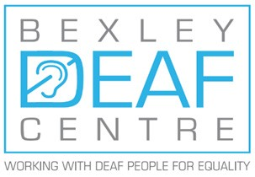

**To find out more please contact:**

**Bexley Deaf Centre,**

**20 Whitehall Lane,**

**Slade Green, DA8 2DH**

**Tel No: 01322 351122**

**Email: info@bexleydeafcentre.co.uk**

[**www.bexleydeafcentre.com**](http://www.bexleydeafcentre.com)

**Registered Charity No: 1039183**

**Courses for 2020**

**Courses at Bexley Deaf Centre**

**Level 1 Beginners: start 22 Jan**

**Wednesdays (am)**

**Level 2: start 23 Jan**

**Thursdays (am)**

**Evening courses off site:**

**Level 1 Beginners: start 22 Jan**

**Wednesday eves, Belvedere**

**Level 2 (details to follow)**

**BSL Level 3: January**

**(Regular Sign Tasters or Deaf**

**Awareness/Sign Skills courses)**

**Learn   
British Sign Language**

