

  Help The Homeless Grant Scheme
  Funding is available for small charities
  with an annual turnover of less than £500,000.
  Funding is only open to support charities who are working wholly or mostly with homeless people
  not for community work, foodbanks or projects
  that are not focused on homelessness.
  Deadline: 20th December 2025.
  More Information
  The Adamson Trust
  Funding is available for families, organisations and registered charities who support children aged between 3 and 17 with a physical, mental or emotional impairment.
  This funding is help with the cost of respite or holidays.
  Deadline: 31st December 2025.
  More Information

  Lionesses Here to Play Fund
  Funding of up to £25,000 is available for grassroots organisations to improve
  football facilities, making them more inclusive safe
  and welcoming for women and girls.
  When applying, please clearly outline how the proposed improvements will benefit women and girls, and how your site will maintain and build on these enhancements in the future.
  No deadline.
  More Information
  The Solidarity Fund
  This funding is for organisations in England that are taking action on the root causes of inequality, such as poverty, disadvantage and discrimination.
  The National Lottery Community want to support and strengthen work that aims to create lasting change, led or shaped by people with lived experience.
  No deadline.
  More Information

  Common Ground Award
  The Common Ground Resilience Fund
  was launched in September to support
  local places, and a key part of this is promoting the important role of the voluntary, community and social enterprise (VCSE) sector.
  The UK government’s Common Ground Award will invest up to £1.7 million capital funding into VCSE sector organisations
  that are bringing people together from different backgrounds, supporting the cost of constructing or renovating facilities, or the purchasing of equipment
  to deliver services.
  Deadline: 21st November 2025.
  More Information
  Migrant Justice, Greater London
  Refugee Action has partnered with the Greater London Authority to support up to six organisations who are looking to initiate or grow their immigration advice and/or support capacity.
  This funding is to support with engagement and capacity building costs, including staff time and the maintenance of service provision whilst taking part in the project (including Immigration Advice Authority (IAA, formerly OISC) training and exam period, if relevant).
  Deadline: 13th November 2025.
  More Information

  Active Travel Innovation Fund
  Active Travel England is inviting organisations who have an innovative behaviour change idea, or from those who wish to scale a proven solution, or service. This funding is designed to enable successful applicants to develop and deliver bold and innovative active travel interventions, aimed at increasing current levels of walking, wheeling, and cycling in England.
  Deadline: 14th November 2025.
  More Information
  Youth Music - Trailblazer Fund
  The Youth Music Trailblazer fund offers grants of £2,000 to £30,000 to organisations in England to run projects for children and young people (25 or under) to make, learn and earn in music. The project should trial work or test a new way of working, sustain a grassroots programme or disrupt the status quo (or all three!).
  Deadline: 21st November 2025.
  More Information

  City Bridge Foundation - Access to Justice
  The first round of funding in this
  programme is aimed at ​‘led by and for’ organisations delivering free social welfare advice, engaging in social action work,
  and supporting systems change. More rounds will open next year.
  On Monday 10 November 2025, full programme information - including
  eligibility guidance and application details will be published on their website.
  A webinar will take place introducing the programme on 11th November 2025 at 11:15am. Book a place here.
  Application to apply for this funding opens 14th November 2025.
  More Information
  Educational Opportunity Foundation
  Educational Opportunity Foundation support work that improves the educational outcomes and life chances of care experienced young people (under the age of 25 and living in the UK).
  They will fund between £30,000 to £90,000 per project for up to three years (maximum £30,000 per year for multi year projects) for projects which work with either care experienced young people, their carers or education professionals to improve access to educational opportunity, improve educational outcomes and improve life chances.
  Deadline: 14th January 2025.
  More Information

  Dying Matters Community grants Programme
  Hospice UK's Dying Matters campaign is working to create an open culture which
  are comfortable taking about death, dying and grief. This grant programme directly supports creative arts and culture projects, events and activities that focus
  on opening up the conversation about death and
  dying. Especially those which reach communities who we know are traditionally less likely to be reached by hospice care and the Dying Matters campaign.
  You must be a member of Hospice UK and based in
  the UK to apply. You can be an adult hospice, children's hospice or provide care for all ages.
  Deadline: 5pm, 5th December 2025.
  More Information
  John Rayner Charitable Trust
  John Rayner (1928-1990) and his wife, Juliet, formed a Charitable Trust in 1985 in memory of their son Simeon, who died in a road accident.
  This trust was primarily to help children and young people who were deprived or in difficulty.
  Funding between £1000 and £5000 is available for charities who support:
  - Children and young people
  - Carers and elderly
  - Medical support
  - Sports for all ages and disabilities
  - The arts
  Deadline: 30th January 2026.
  More Information

  Warburtons Financial Giving
  Warburtons Community Grants provides small grants up to £400 to support charitable organisations towards broader activities which improve Health, Place or
  Skills for families in their community.
  Based on their localism approach, their community investment funds are allocated to local bakeries and depots. This helps their Community Champions to make the best decisions for their local communities. They will use your postcode to understand which of their sites is closest to you and they will then receive the application and make a decision.
  Deadline to apply is not yet confirmed. Community grants are decided on a quarterly basis.
  More Information
  Blue Spark Foundation
  BlueSpark Foundation aims to help children and young people reach their full potential by supporting projects which have the following objectives:
  - Encouraging Independence
  - Developing team working skills
  - Developing self confidence
  - Promoting creativity & individuality
  - Encouraging aspiration
  - Enhancing educational achievement
  - Widening educational horizons
  Please note, BlueSpark provides funding for relatively small-scale projects which might not happen without the support of BlueSpark.
  No deadline, applications are reviewed on a rolling basis at approximately 8 week intervals.
  More Information

  London Growth and Resilience Programme 2026
  This opportunity from the School for Social Entrepreneurs (SSE) could benefit charities, not-for-profits or community organisations in London who want to start or grow trading and build financial resilience.
  The London Growth & Resilience Programme offers 18-month support combining two grants with hands-on learning and mentoring.
  To be eligible, you must be a London
  based organisation, 3+ years old with a minimum of £50k income.
  Deadline: 12pm, 18th December 2025.
  More Information
  The Radcliffe Trust
  Radcliffe Trust is offering grants between £2,500 and £7,500 for charities, not-for-profit groups across the UK to support projects in the areas of music or heritage and crafts.
  The Trust supports the development of skills, knowledge, and experience in the UK’s traditional heritage and crafts sectors, including:
  • Emerging craftspeople
  • Craft and conservation training and projects
  • Creative work by designer-makers
  • Capacity-building initiatives
  • Therapeutic projects focused on skills development.
  Deadline: 31st January 2026.
  More Information

#iwill Fund 2025

This funding is for work that helps young people up to 20 years old, or up to 25 if they have additional support needs in England address the issues that matter most to them and their community.
The funder calls this youth social action.
You can apply if you are a funder, and want to use this money to give out funding to others. Or you can apply to run activities directly with young people.
Deadline: 12pm, 19th November 2025.

More Information

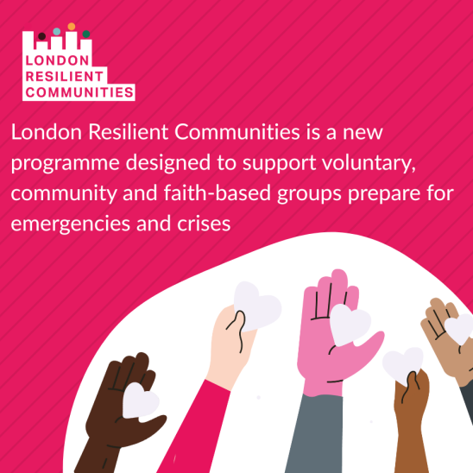
London Resilient Communities is a London Resilience funded programme that supports the capital’s voluntary, community and faith sectors to be more resilient in the face of emergencies.
There are two grants available:
- Developing Community Emergency Plan: £500
- Becoming a Community Resilience Hub: £1,000
Successful applicants will also have access to a series of online sessions providing further expert support, and the opportunity to network with their fellow grantees. Attached to each grant is a specific set of required actions, which approved grantees will need to complete in order for them to receive the grant.
Deadline: 5pm, 10th December 2025.
More Information

