A Compact for Bexley

Working together for Bexley’s Communities

December 2024

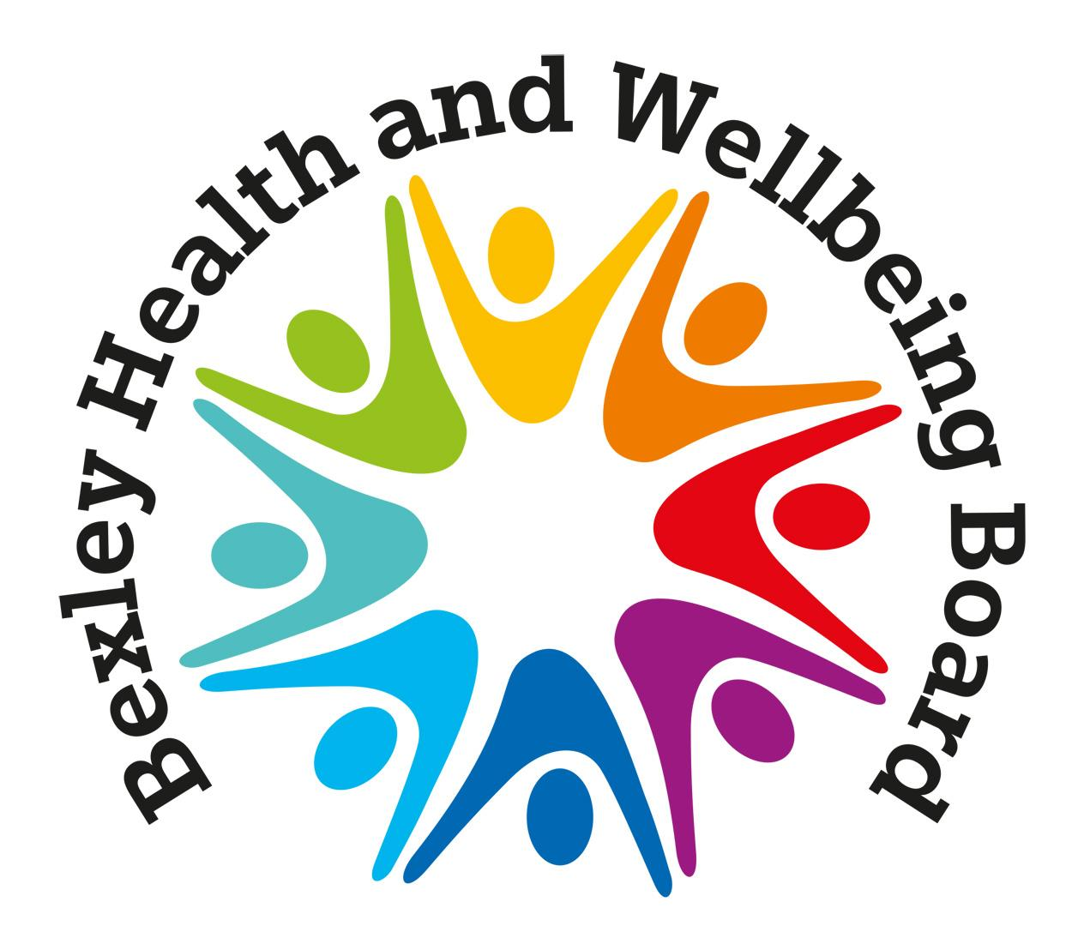

FOREWORD

# Paul Thorogood, Chief Executive, London Borough of Bexley

Bexley is greatly enriched by our passionate, committed and diverse voluntary and community sector, where all local organisations, large and small, work together in a strong, honest and positive partnership with the statutory sector. Everyone has the same goal, which is to make Bexley even better, in line with our Bexley Plan 2022-26. We work together to support all our residents to live the best lives possible and to reach their potential.

We recognise that local statutory partners and the voluntary and community sector are facing the challenges of rising demand, limited resources, and changing needs.

During these challenging times, we want to be good at what we do, to be fair and inclusive. We are a values driven organisation, we believe in being open and accessible; being innovative; listening and responding to residents and partners; providing leadership. working in collaboration and in making a genuine impact. We recognise that by working together with our partners, we are stronger and can make a more positive impact. By working closely together in innovative ways, we can get the most from our joint resources and target them to achieve the best for Bexley.

The impressive partnership work displayed during the pandemic shows us what we can achieve when we work together. We want to build on that shared spirit and strength. This Compact will give us the founding principles for our important work together.

# Jattinder Rai, Chief Executive, BVSC (Bexley Voluntary Service Council)

# As the Chief Exec of Bexley’s local infrastructure organisation, I see first-hand (and I’m immensely proud of), the impact our voluntary and community sector (VCS) has in Bexley. The VCS has a pivotal role in strengthening the fabric of community, improving lives and ensuring voices are heard.

# The partnership between the Voluntary & Community Sector and statutory partners has been key to the success of local organisations and has continued to strengthen year on year. Working together we’ve achieved a huge amount to improve the lives of residents.

# Through this refresh of this Compact we have a clear framework that demonstrates our shared commitment to continue great partnership working, achieve greater outcomes and support Bexley’s communities to continue to grow and flourish.

EXECUTIVE SUMMARY

**WHAT IS A COMPACT?**

The Compact is an agreement between the statutory sector and the voluntary and community sector (VCS). The agreement has been developed in partnership and aims to ensure that the statutory sector and the VCS work effectively together to achieve common goals and outcomes for the benefit of communities.

The Bexley Compact sets out some shared commitments between the statutory sector and the voluntary and community sector (VCS) in Bexley.

We have a shared commitment to:

1. Nurturing a diverse and independent voluntary and community sector
2. Effective & transparent commissioning, design and monitoring of programmes & public services
3. Communicate promptly, openly and with respect to foster trust and good working relationships for the benefit of our community
4. Be inclusive, accessible and fair

In aiming to achieve these four commitments, we have asked that the voluntary and statutory sectors sign up to some key undertakings to improve their process; practices; thinking and behaviours.

Key undertakings for the statutory sector:

* Respect and uphold the independence of Voluntary and Community Organisations (VCOs) to deliver their mission, including their right to campaign, regardless of any relationship, financial or otherwise, which may exist.
* Ensure greater transparency by making data and information more accessible, helping VCOs to challenge existing provision of services and access new markets.
* Include the VCS voice within partnership forums wherever possible.
* Recognise that VCOs have a role to play in developing and shaping services and policy through co-design and co-production and provide opportunities for VCOs to do so.
* Work to remove barriers that may prevent VCOs accessing public sector funding (see action plan), thereby enabling smaller organisations to become involved in delivering services where they are best placed to achieve the desired outcomes.

Key undertakings for the voluntary and community sector:

* Raise awareness of the impact that voluntary action and volunteers have on individuals, local communities and the wider VCS.
* Be open to hearing about performance issues with your service and take appropriate action as early as possible.
* Proactively engage in the commissioning process providing information and advice about communities.
* Collaborate with other VCS colleagues in taking active leadership roles in ensuring service users voices are heard on key issues.
* When campaigning or advocating, ensure that robust evidence is provided, including information about the source and range of people and communities represented.

Shared Undertakings:

* Place the needs of the community first in considering the impact of changes to programmes.
* Ensure consistent participation in the proportionate monitoring of commissioned services.
* Understand on both sides that reduced budgets affect everyone; work together to weave resources to arrive at outcomes most effectively.
* Be transparent about acknowledging success and failure in design and delivery of programmes.
* Agree not to speak badly of one another in public and be clear on what type of campaigning is acceptable.
* Develop and engage in programmes that support partnership working between the sectors and develop increased awareness of the roles, responsibilities, and constraints that each of the sectors operate within.
* Consistently demonstrating inclusive, nurturing leadership at all levels – learning and development activity will support this.
* To determine a mutually agreeable timetable for review of the Compact

**WHY IS THERE A NEED TO REFRESH THE COMPACT?**

The Compact was last updated in 2016 and since then our ways of working have changed, partly in response to covid and crisis management, partly due to changes in statutory sector governance. The Bexley Voluntary Forum were keen that we revise the compact principles and commitments in this context.

This Compact follows the principles of the National Compact but also reflects local circumstances. It sets a structure for both the VCS and statutory sectors to engage with each other and has been co-produced by key partners across sectors. We hope to inspire new partners to sign up and support the commitments underpinning the Compact.

By refreshing the Bexley Compact we intend to:

* Raise mutual awareness, respect and honesty between the sectors
* Build trusting relationships and foster a spirit of collaboration
* Show that the aims and ambitions we have in common are greater than the perceived differences that might have caused barriers in the past
* Create transformation and success
* Work together to improve local communities by making them stronger and more resilient

**CHANGES IN STATUTORY SECTOR GOVERNANCE**

* **INTEGRATED CARE SYSTEMS**

Integrated Care Systems were established nationally by the Health and Care Act 2022. As of July 2022, we became [Our Healthier South East London Integrated Care System](https://www.ourhealthiersel.nhs.uk/) (ICS). The South East London ICS aligns with the administrative boundaries of the SE London councils– Bexley, Bromley, Greenwich, Lewisham, Southwark and Lambeth

The ICS brings together local health and care organisations and local councils to design care and improve population health, through shared leadership and collective action. Organisations work in close partnership, share information to fully understand the needs of the population, and collaborate to manage the common resources available.

ICSs have four key purposes:

1. Improving outcomes in population health and healthcare

2. Tackling inequalities in outcomes, experience and access

3. Enhancing productivity and value for money

4. Supporting broader social and economic development

* **THE INTRODUCTION OF THE BEXLEY WELLBEING PARTNERSHIP**

Each borough has a Local Care Partnership composed of local ICS Directors, NHS, community and mental health providers, Primary Care Networks (GPs), and Local Authority Social Care services (both Children’s and Adults). In Bexley our Local Care Partnership is called the Bexley Wellbeing Partnership.

Bexley has a ‘place-based’ system of care, in which a range of partners work together to provide person-centred care in a proactive and integrated way. Place based means within the administrative boundary of the local authority. This new system of care will see partners working together on a strategic level to understand the population and agree how resources can be used to achieve shared objectives.

The Bexley Wellbeing Partnership brings together 17 local health and social care organisations who have pledged their commitment to joining up how they work (systems, processes, technologies, budgets and outcomes) to improve the health and wellbeing of people in Bexley. Partners seek to ensure that Bexley residents can start well, live well and age well with appropriate interventions in place, from prevention through to specialist services.

**The Shared Vision and Values for transforming Health & Care in Bexley are:**

* Delivering effective integrated health, social care and wider services that best meet the needs of Bexley’s population by adopting a ‘place-based’ approach to health and care
* Developing person-centred care services driven by improved outcomes and experience
* Integrating services where it beneficial to do so
* Shifting care to more appropriate settings, including in the community and in the home where possible
* Improving the emphasis on the prevention of ill health and promotion of health and wellbeing
* Narrowing the inequalities gap in health outcomes between the most affluent and most deprived communities in Bexley
* Contributing to the wider growth and sustainability of a vibrant, thriving Bexley community including employment, housing, education and economic growth.
* **JOINT COMMISSIONING**

The joint commissioning service for the Council and the ICS ensures that commissioning is consistent and offers maximum opportunity for co-production. There are several good examples of co-production between the Voluntary and Community Sector, the Council and the ICS, including –

* **Community Connect,** our **Social Prescribing** service, is jointly commissioned between London Borough of Bexley and Bexley Wellbeing Partnership. It is delivered by BVSC. Bexley's social prescribing model offers a **flexible and responsive service** whereby GPs can directly access non-medical support for patients through the hundreds of different VCS organisations in the borough. This can help patients achieve better health and wellbeing. One of the critical success factors is the **effective partnership working** between the Bexley Wellbeing Partnership, the Council, GP practices, the VCS, and our evaluation partners (the University of Kent).
* **Made in the Estuary £1m grant** is part of the Creative People and Places programme and focuses on **empowering individuals to create their own work,** to gain confidence in taking part in the arts and to **celebrate their cultural** **voice**. These activities include a community radio station, festivals and craft workshops. It was jointly developed by the Council’s Thamesmead Regeneration team, Peabody Community Foundation's Fundraising team, Thamesmead Socio-economic teams, and our partners. Just twelve projects across England have been awarded funding.
* Bexley’s **Community Champions** were launched in June 2020. This built on the collaborative work with BVSC (through the Volunteer Centre) during the first lockdown in 2020, which helped to place volunteers who came forward to assist their neighbours. Over 100 volunteers were co-ordinated to deliver shopping and medication requests which came in via the LBB contact centre. Community Champions were vital in helping to promote the need for people to get vaccinated and have **undoubtedly contributed to the high take-up of the Covid vaccine in Bexley** compared to other boroughs. Community Champions also helped in the planning and execution of outreach projects to assist the rollout of the programme.

A COMPACT FOR BEXLEY

**Commitment 1**

NURTURING A DIVERSE AND INDEPENDENT VOLUNTARY AND COMMUNITY SECTOR

**Undertakings for the statutory sector:**

* **Respect and uphold the independence of Voluntary and Community Organisations (VCOs) deliver their mission, including their right to campaign, regardless of any relationship, financial or otherwise, which may exist.**
* Consider a diverse range of ways to resource the VCS (grants, infrastructure, contracts, loan finance and use of premises) - be proportionate in approach to encourage organisational diversity.
* Promote and uphold good volunteer management, recognising that volunteers make an important contribution to Bexley both socially and economically.
* Commit to multi-year funding where appropriate and where it adds stability for the VCS sector and beneficiaries.
* Ensure VCOs are supported and resourced in a reasonable and fair manner where they are helping the statutory sector fulfil its aims.
* Continue to invest in ‘infrastructure’ support ensuring there are resources to assist VCOs capacity, capability and sustainability.

**Undertakings for Voluntary and Community Organisations (VCOs):**

* Explore new ways of working and diversify funding streams.
* Provide appropriate training for trustees.
* **Demonstrate the impact that voluntary action and volunteers have on individuals, the VCS and local communities.**
* Ensure robust governance arrangements so that organisations can best manage any risk associated with service delivery and financing models, including giving funders early notice of significant changes in circumstances.
* When campaigning or advocating, ensure that robust evidence is provided, including information about the range of people and communities represented.
* Ensure independence is upheld, focusing on the cause represented.
* Work towards achieving appropriate quality standards.

**Shared Undertakings:**

* Strong governance practice
* Develop and engage in programmes that support partnership working between the sectors and develop increased awareness of the roles, responsibilities, and constraints that each of the sectors operate within.
* **Agree not to speak badly of one another in public and be clear on what type of campaigning is acceptable. Seek early resolution**.
* Understand on both sides that cuts affect everyone; try to protect outcomes for residents where possible.
* Use resources effectively and explore collaboration of premises, facilities, and leases.

**Commitment 2**

# COMMUNICATE PROMPTLY, OPENLY AND WITH RESPECT TO FOSTER TRUST AND GOOD WORKING RELATIONSHIPS FOR THE BENEFIT OF OUR COMMUNITY;

**Undertakings for the statutory sector:**

* Be upfront about funding constraints and expectations around timescales when entering financial relationships.
* Give a minimum of three-months’ notice in writing when a decision is made to change or end a funding relationship or other support, apart from in exceptional circumstances, and provide a clear rationale for why the decision has been taken.
* Publish a register of grants and contracts awarded.
* **Include the VCS voice within partnership forums wherever possible.**
* Where there are restrictions or changes to future resources, discuss with VCOs the potential implications as early as possible, establish decision-making timescales and recognise the importance of sticking to them and give organisations the opportunity to respond and assess the equalities impact before a decision is taken.

**Undertakings for Voluntary and Community Organisations (VCOs):**

* Be upfront about project risks and be open to hearing about performance issues with the service and take appropriate action as early as possible.
* Give a minimum of three-months’ notice about any changes to service provision, apart from in exceptional circumstances, and provide a clear plan for meeting funding objectives.
* Expect statutory partners to review your annual accounts.
* Recognise that the statutory sector can legitimately expect VCOs to give public recognition of its funding.
* Plan for the end of funding to reduce any potential negative impact on beneficiaries and the organisation. Give early notice of change in service delivery to beneficiaries.

**Shared Undertakings:**

* Recognise our common goals. Put the needs of the community first.
* Support each other with working towards achieving their priorities.
* Ensure consistent participation in the proportionate monitoring of commissioned services.
* If a programme or service is encountering issues, identify this as early as possible, give clear messages to the other party and agree a timetable of actions to improve performance before deciding to end a financial relationship.
* Negotiate realistic timelines for delivery of outcomes from the outset.
* Look at efficiencies and smart working where possible and sharing resources where appropriate.

Commitment 3

THE EFFECTIVE & TRANSPARENT COMMISSIONING, DESIGN AND MONITORING OF PROGRAMMES & PUBLIC SERVICES;

# 

**Undertakings for the statutory sector:**

* Provide, wherever possible, at least three-year funding agreements, recognising that this improves confidence, stability, and sustainability. Consider five-year agreements with strategic delivery partners.
* Discuss and allocate risks to the organisation(s) best equipped to manage them. Where prime contractors are used, ensure they adhere to the principles of this Compact in allocating risk.
* Adhere to social value policy to encourage collaborative local partnerships.
* Work to remove barriers that may prevent VCOs accessing public sector funding, thereby enabling smaller organisations to become involved in delivering services where they are best placed to achieve the desired outcomes.
* Work to a published funding or commissioning framework.
* Provide timely information to the voluntary and community sector about changing public policy, development of new service outcomes, and related funding opportunities allowing sufficient time for bids or tenders to be prepared, including collaborative bids.
* Include VCS in the design phase, where appropriate, - with VCS support it might be possible to provide better value for money by doing something differently.

**Undertakings for Voluntary and Community Organisations (VCOs):**

* If receiving public money, ensure you can demonstrate deliverables and outcomes.
* When putting forward ideas, focus on evidence-based solutions, with clear proposals for positive outcomes.
* Proactively engage in partnerships and commissioning processes - providing information and advice about communities to inform future service planning.
* Engage in consultation and provide feedback to statutory partners when collecting the views of local residents.
* Collaborate with VCS colleagues in taking active leadership roles in ensuring service users voices are heard on key issues.

**Shared Undertakings:**

* Recognise and prepare for some funding and some projects that will be time limited.
* Participate in consistent monitoring meetings - requesting and providing information that is proportionate to the value of the grant/contract.
* Demonstrating impact is the responsibility of both commissioner and VCS organisation.
* Be transparent about acknowledging success and failure in design and delivery of programmes.
* Share information and data, policies, and best practice.
* Contribute positively to reviews of programmes and funding practice.
* Consider the financial stability of organisations when developing and entering funding models - recognising core costs. Acknowledge that voluntary organisations have the right to use the full cost recovery process but may choose not to do so. Recognise that when VCOs apply for a grant they can include appropriate and relevant overheads, including the costs associated with training and volunteer involvement.

**Commitment 4**

BE INCLUSIVE, ACCESSIBLE AND FAIR

**Undertakings for the statutory sector:**

* Seek to provide accessible spaces for residents to associate - like libraries.
* Undertake Equalities Impact Assessments when making changes in policy or investment and use this to inform decision making.
* Recognise the VCS can legitimately disagree with national and local policy.
* Ensure equal treatment across sectors, including reporting and monitoring arrangements, when tendering for contracts.
* To ensure transparency, and to assist in the fulfilment of the [Public Sector Equality Duty](https://view.officeapps.live.com/op/view.aspx?src=https%3A%2F%2Fwww.equalityhumanrights.com%2Fsites%2Fdefault%2Ffiles%2Fguidance-essential-public-sector-equality-duty-england_0.docx&wdOrigin=BROWSELINK)- the Equality Act requires public authorities to publish the equality objectives, at least every 4 years and information to demonstrate their compliance.

**Undertakings for Voluntary and Community Organisations (VCOs):**

* Develop platforms and participate in networks which work to tackle inequality, with an objective of creating collaboration and leadership amongst marginalised communities.
* Help to facilitate feedback from users and communities to the statutory sector to help improve delivery of programmes and services.
* Publish Trustee Board inclusion data where possible.
* Provide anonymised data on Equalities Impacts where it will support the statutory sector to better understand an issue.
* Ensure the needs of communities are met by providing services to targeted groups, specifically under-served communities with funding that has been made available.

**Shared Undertakings:**

* Ensure that appropriate safeguarding policies and practices are in place.
* Seek out diverse voices when shaping services.
* Create an environment that promotes disclosure of diversity characteristics and understanding of why that is important.
* Increase the visibility and effectiveness of champions and staff networks.
* Consistently demonstrate inclusive, nurturing leadership at all levels – learning and development activity will support this.
* Take seriously and act upon allegations of inappropriate language, situations or practices and have the skills to mediate and investigate issues as soon as they arise, promptly at the root cause.
* Actively challenge policies, culture and behaviours which lead to discrimination, inequality, and exclusion
* Recognising that it can take time to develop trust and build relationships with new and emerging communities.

# Conflict Resolution

# In the event of the dispute resolution the following should happen:

**Stage 1:**

1.1. Commissioned Orgs: VCS organisations and Commissioner to try to resolve the issue informally e.g. one-off late payment of invoice.

1.2. Non-commissioned VSC organisations: go straight to stage 2

**Stage 2:**   
Raise with BVSC who will identify a VCS CEO, senior commissioner/Head of Service/Deputy Director level officer with which to raise/elevate the issue e.g. objections to monitoring requirements or de-commissioning processes

**Stage 3:**   
If a policy decision is required then it may be taken to the relevant VCS Governing Board of the organisation involved, and/or the Strategic Commissioning Board.

# Compact Action Plan

We recognise that making the compact requires commitment and action from both the statutory and voluntary and community sectors. This action plan sets out our combined steps to implementing an effective Compact. The Compact Working Group will liaise with the appropriate officers and VSC organisations to carry out and review actions on an annual basis and as required.

|  |
| --- |
| **Targeted support to commissioning and VCS workforce to think about how the compact principles might be applied in their area of work.** |
| **Building stronger relationships and understanding:**   1. BVSC to run ‘Introduction to the Voluntary and Community Sector’ for statutory colleagues. 2. LBB and ICS to consider running ‘Introduction’ sessions for new officers and key VCS staff. 3. Consider setting up a partnership work shadowing programme across sectors. 4. Roll out the LBB Staff Volunteering Scheme, working with the BVSC Volunteer Centre. |
| **Communications:**   1. Working Group: Develop a one-page infographic of the Executive Summary. 2. Working Group: Develop Comms Plan to keep the Compact alive including;   2.1. a regular item at the Bexley Voluntary Forum for emerging themes  2.2. inclusion of ‘Understanding The Compact’ as part of LBB; ICS and voluntary sector inductions.  2.3. BVSC to feature The Compact on the BVSC website. |
| **General**:   1. Establish clear lines of communication between BVSC and the Council via the Director of Integrated Commissioning for Compact issues. |
| **Strategic Planning and Property:**   1. Consider cross sector senior level discussion about principles around renting to the voluntary and community sector. 2. Consider producing a central list of available properties in the borough for VCS usage/office bases. 3. Consider early involvement with planners i.e. produce a register for VCS organisations looking for property. |
| **Partnership Working**   1. Regular informal meetings between BVSC and health and council partners to discuss operational issues where compact principles might need to be applied more effectively. |
| **Commissioning, Procurement and Finance:**   1. Ensure well managed and transparent application and tendering processes, which are proportionate to the desired objectives and outcomes of programmes. 2. Inform VCS of commissioning opportunities with as much notice as possible. 3. Ensure that procurement processes including timing do not disadvantage smaller voluntary organisations. 4. Make data and information more accessible, helping VCOs to participate in the development of services more effectively. 5. Recognise different kinds of quality standards and have an active role in agreeing locally recognised quality standards. 6. Council to review its policy around inflationary uplift on grants and contracts (including extensions to contracts). |
| **VCS Monitoring:**   1. Be open and transparent about reporting, recognising that monitoring, whether internal or external, is an aspect of good management practice. 2. Be up to date on the easiest way to evidence outcomes and share best practice in monitoring. 3. Demonstrate the social, environmental, or economic value of the programmes and services provided, where appropriate. |
| **VCS representation and voice in service design**   1. Share expertise, knowledge and skills gained from being able to engage closely with service users. Help to identify needs in the community. 2. Help facilitate feedback from users and communities to the statutory sector to help improve delivery of programmes and services. |

For further information about Bexley’s Compact, please contact:

**Director of Integrated Commissioning:** [**Alison Rogers alison.rogers@selondonics.nhs.uk**](mailto:Alison%20Rogers%20alison.rogers@selondonics.nhs.uk)

**CEO Bexley Voluntary Service Council:** [**Jattinder Rai jattinder@bvsc.org.uk**](mailto:Jattinder%20Rai%20jattinder@bvsc.org.uk)