EMIS – How to register a new patient for online services

- Go to Registration module
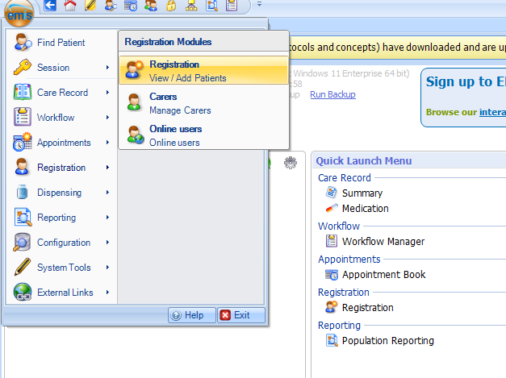

- Search for the patient, and make sure they have an up-to-date mobile and email address recorded.
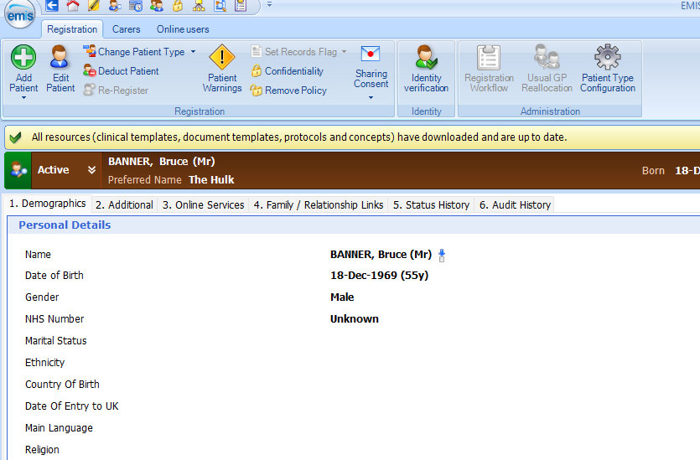

- Go to the third tab “3. Online Services”, click “Add online user…” then “Add current patient”.
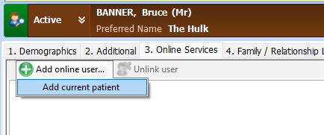

- Add at least one method of ID verification for the patient
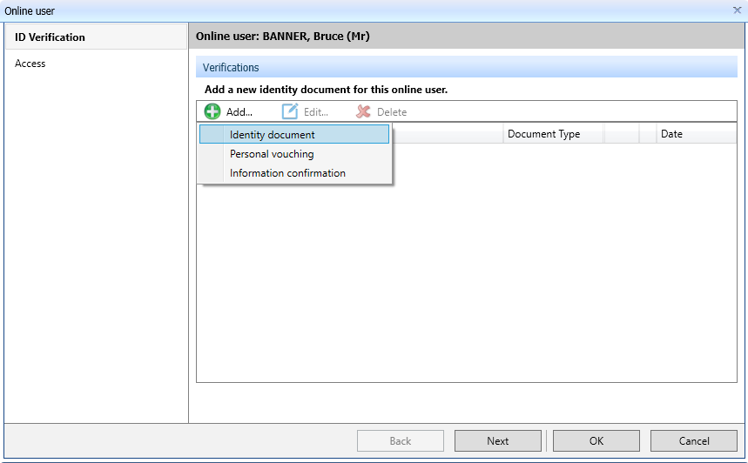

- Amend their online access.
This will only affect their historic record as all current and future information will be automatically made available online due to the ‘Accelerated Access to Patient Records’ programme.
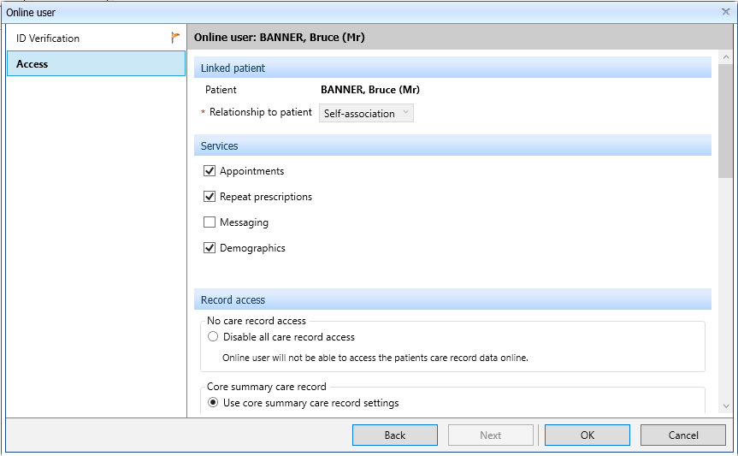
EMIS – How to amend online access and re-issue their account PIN

- Go to the Online users module
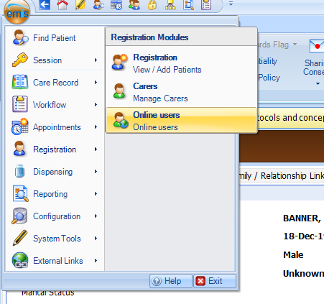

- Find an online user or the current patient will be loaded.
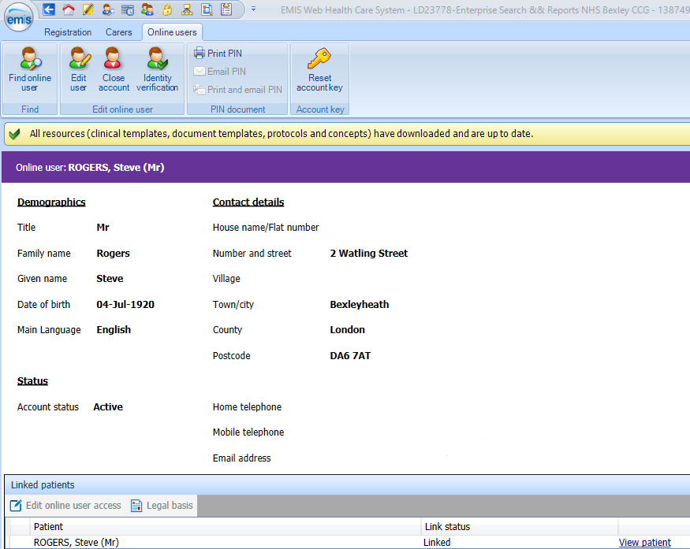
You can edit their historic online access by clicking on their name at the bottom, under “Linked Patients”, then clicking on “Edit online user access”.

- Additionally, you can reset or re-issue their account PIN using these controls on the banner at the top.
