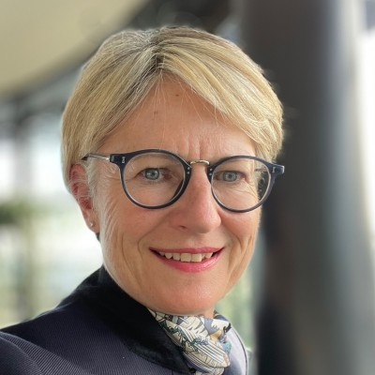

Nicky Moffat CBE

Nicky’s first career spanned 27 years in the Armed Forces, leading people across multiple roles, including as Commander of a Training Regiment and Director of the 4,500 soldiers within her Branch. As a Private Secretary, she worked at the heart of Government, supporting the Secretary of State for Defence on fast-moving operations in Iraq, Afghanistan, Sierra Leone and the ‘Foot and Mouth’ crisis in Cumbria. She left in 2012 - in the rank of brigadier - the most senior woman in the Army at the time. Speaking out (on Radio 4, Newsnight, Good Morning and other flagship programmes), she regularly advocated for a more inclusive approach to the employment of women. She set up *What Good Leadership Looks Like,* to support companies and organisations committed to the development of their people. She consults and facilitates, offering practical developmental advice to teams and individuals, including as coach and mentor. She’s an in-demand keynote speaker, having practised and honed her art over the past decade.

Nicky made her TV debut in the 2018 BBC/Netflix living history series *Churchill’s Secret Agents: the New Recruits.* She works also with the Arts - providing authentic military perspective - alongside creative teams bringing opera and musical theatre (*War Requiem, South Pacific* and *The Sound of Music…)* to the stage. Nicky retains her military links as Life Vice President of the Women’s Royal Army Corps Association, a charity providing support - camaraderie and benevolence - to female veterans.