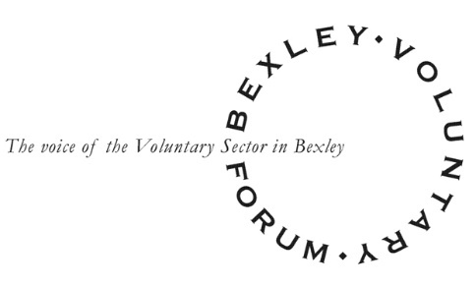
Bexley Voluntary Forum Terms of Reference
New draft at March 2021
Purpose of the Forum
The purpose of the Voluntary Forum is to provide a space where all voluntary and community organisations in Bexley can meet, find out about key strategic priorities and plans impacting on their communities, and have an opportunity to voice their views.
Membership
Membership of the Voluntary Forum will be open to charitable, non-profit organisations whose work contributes to the residents of Bexley, except where the organisation
- is not committed to equality of opportunity
- is a political party
- has more than half its trustee board or committee representing the statutory or private sectors.
Organisations can apply for membership while completing their BVSC membership forms, or by contacting the BVSC office on 01322 524682 or email information@bvsc.co.uk. (in recent times we have not asked groups to apply for membership and it was agreed at the Voluntary Forum meeting in 2020 that membership was no longer required).
Governance Arrangements
The Voluntary Forum will be administered by Bexley Voluntary Service Council. The Chair will be elected by members at an annual meeting, through a nomination process coordinated by BVSC.
Representatives for Adult Health and Social Care (4), and Children and Young People (4) will also be elected at the Voluntary Forum.
Representatives will serve for a period of up to three years (review after year 1 and year 2).
Practical Arrangements
Voluntary Forum meetings will take place quarterly and will receive regular updates from the relevant strategic boards, the BVSC Partnership Officer and Bexley Healthwatch)
The BVSC Partnership Officer will work closely with the Chair to agree the agenda for meetings.
Functions of the Voluntary Forum
- To share information about the strategic priorities and plans impacting on Bexley residents and communities
- To hear views and receive feedback on these plans from voluntary and community organisations
- To collectively identify new and emerging needs and gaps in services and feed this information in to developing plans
- To feed these views back as appropriate, formally or informally, at relevant partnership meetings
- To offer the opportunity for organisations to network and find out more about each other’s work

