Information for applicants

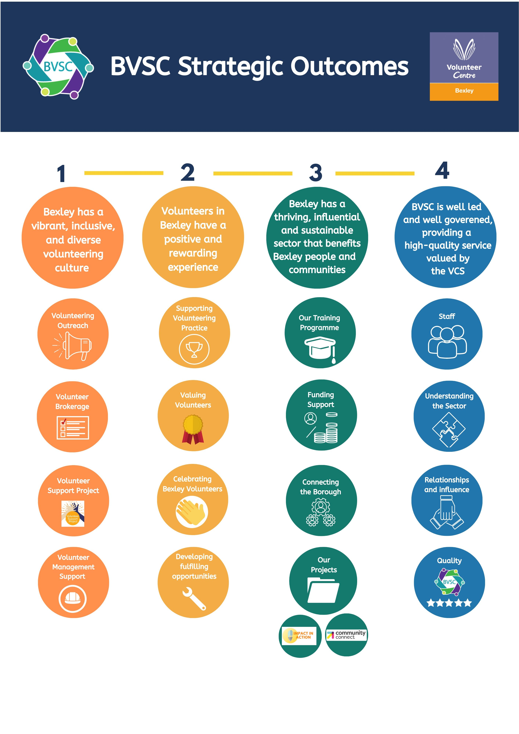

Summary of Terms & Conditions of Employment

- Annual Leave
Annual leave entitlement for this post is 25 days plus 8 bank holidays. In total your entitlement is 33 days. In addition, the BVSC office is closed between Christmas and New Year but you will be paid for this period. You are also entitled to a paid day off on your birthday. All holiday will be on a pro-rata basis for part time hours. We have a holiday purchase scheme where you can ‘buy’ up to 5 days annual leave (this means they are unpaid).

- Hours of Work
Full time hours of work are 35 per week excluding lunch. Core hours are 9.30am to 4.00pm. Part time hours are included in core hours, but can be negotiated with your line manager ensuring organisational needs are met.

- Pensions
BVSC is able to contribute to a pension scheme for eligible employees. Employees must contribute a minimum of 3% of salary, BVSC will contribute 6% of salary.

- Sickness Provision
Length of service | Sick Pay
During probation | SSP only
Up to 2 years’ | 1 month full and 1 month half pay
Between 2 and 3 years | 2 month full and 2 month half pay
4 or more years | 3 month full and 3 month half pay

- Travel
Any travel within the borough and to neighbouring boroughs will be reimbursed at the Inland Revenue tax-free rate.
- Commitment to Training & Development for all Staff
BVSC recognises the importance of continuous learning and development to both the individual and the organisation.

