Social Prescribing in Bexley
Helping you to live a healthy life with others.
Our health can be affected by lots of
different things.

We might feel unwell if we have money
problems.

 | If we are not sleeping very well.
 | If we are worried or upset.
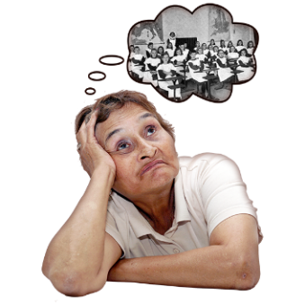 | If someone close has died or a  relationship ends.
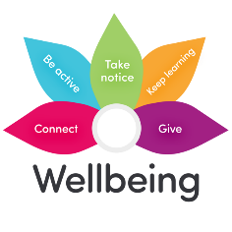 | The help we need may not be tablets or  other medicines.
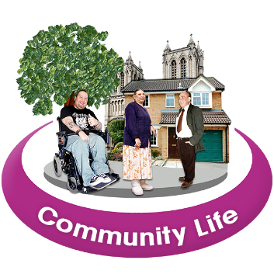 | We can get different types of help in the  community where we live:  - Friendship groups  - Exercise  - Healthy eating  - Advice and support  - Volunteering and getting involved
A Social Prescriber/link worker is a
person who can help you with this.

It is FREE so you don’t pay anything.

If you are over 18 and registered with a
Bexley GP you can use this service.

Any member of the GP Practice teams
can refer you to us or you can contact us
yourself.

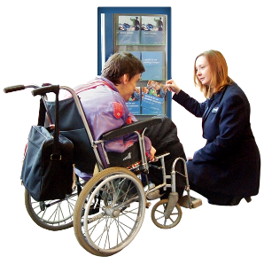 | A Social Prescriber can then meet you,  find out how you are feeling and what  help you need.
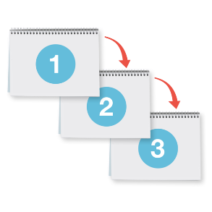 | They can help you to make a plan that is  right for you.
You if you think we can help you get in
touch.

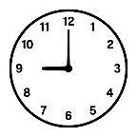 | Call on 01322 524682 and press  option 1  (Monday to Friday, 10am-4pm)
Email us at:

communityconnect@bvsc.co.uk

