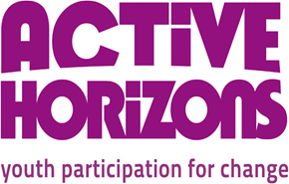

Personal Details

Full Name
Contact Address
Email
Telephone Number
National Insurance

Post applied for ____________________________________________

Experience and skills: Please read the Person Specification carefully and indicate how you will fulfil this role. Please give concrete examples which demonstrate your ability to meet the requirement. Avoid using language such as “I am passionate about this job or I have excellent communication skills” without demonstrating those qualities. Also do not use acronyms as this will jeopardise your chances of getting short-listed. This information will be used by the recruitment panel to shortlist you for interview. You can give details of any extracurricular activities you have been involved in, and provide details of any positions of responsibility you have held e.g. in paid / unpaid work, education, clubs, societies or charity work.

Education and Training: Please outline your educational background from secondary school onwards, qualification obtained and dates.

Name of course and  place of study | Qualifications  and awarding body | Dates  from/to

Previous Employment and Work History:
Name and Address of employer | Job Title and  Main duties | Dates of employment & reason for leaving | Paid/Voluntary

REFERENCES
Please give details of two people, not related to you, who may be approached for references as to your suitability for the post. One should be your present employer, Teacher or University Lecturer. The second should be someone who is able to comment on your character abilities.
Name:  Position:  Address:  Telephone:  Email: | Name:  Position:  Address:  Telephone:  Email:

Declaration

I certify that the information I have given above is accurate to the best of my knowledge.

Signature: Date:

Important!
Please complete all sections of this application form and email to
info@activehorizons.org.uk
Please insert your full name as the subject heading for your email.

